# ......................................................................................................................................................

**NAME –VAIBHAV NEGI COURSE - MCA (2nd - ‘B’) STUDENT ID - 20711097**

**......................................................................................................................................................**

**Problem statement**: Perform Connecting two PCs /computer using peer to peer in Packet Tracer.

**Objective**: To understand how to connect two PCs /computer using peer to peer.

# Description:

**STEP 01 -** Open PACKET TRACER and go to the bottom left side of packet tracer window and then click on **END DEVICES** and select icon of PC then drag and drop PC icon from it in the workspace.

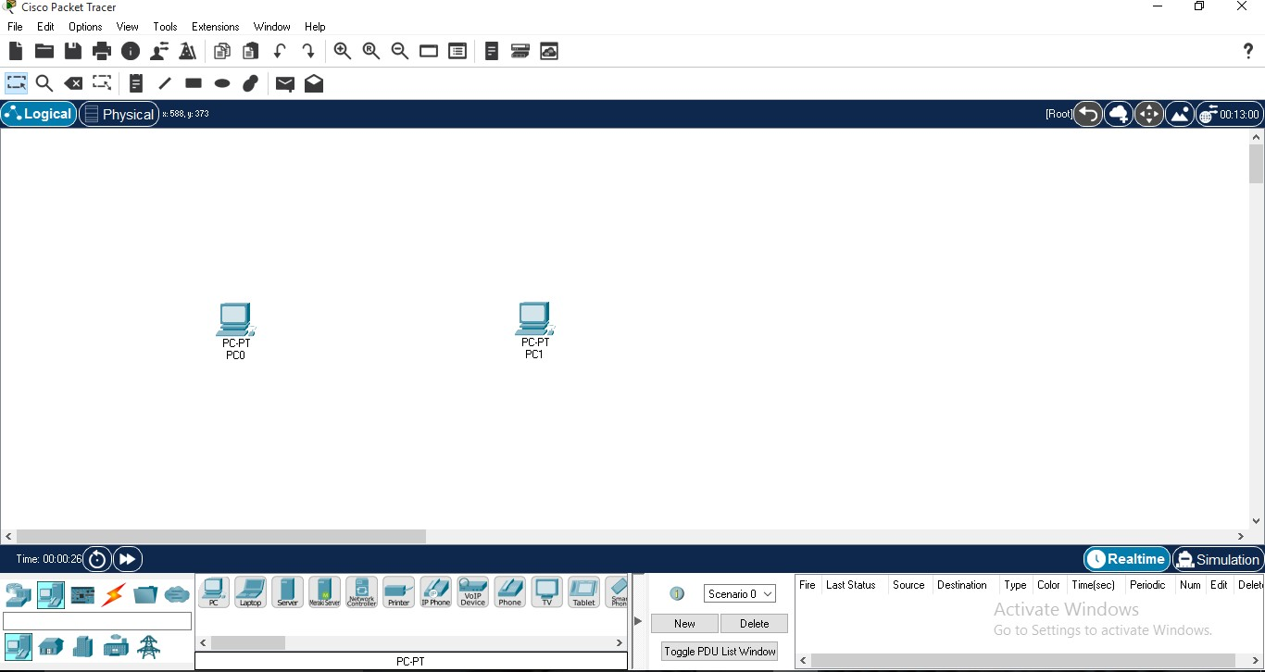

**STEP 02 -** Then again go to the bottom left side of packet tracer window and then click on **CONNECTIONS** since we are using the same device therefore select **copper cross over cable.** Then right click on PC0 and click on FastEthernet0.

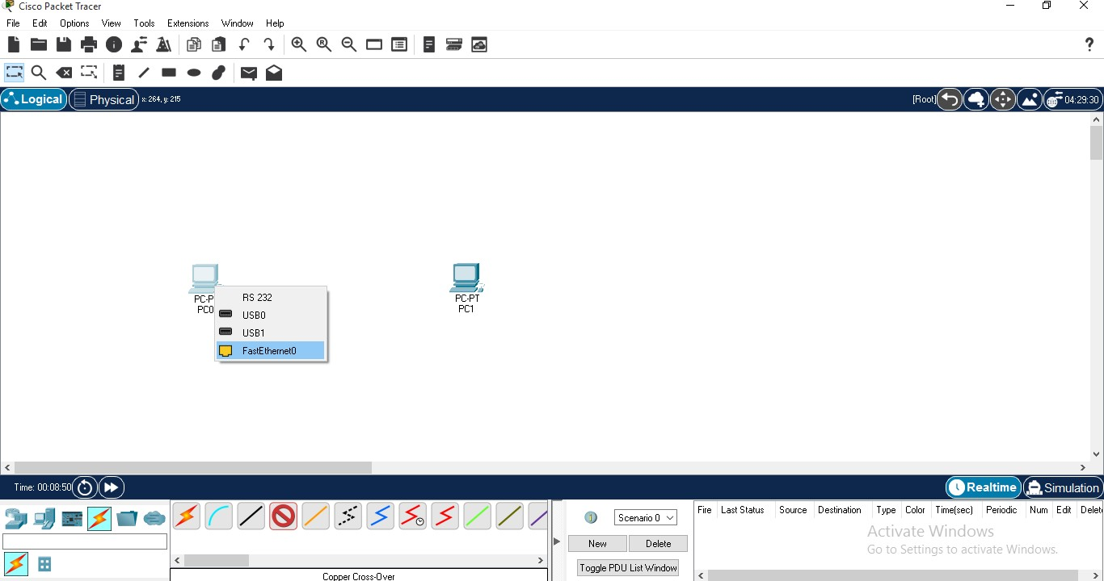

click FastEthernet0.

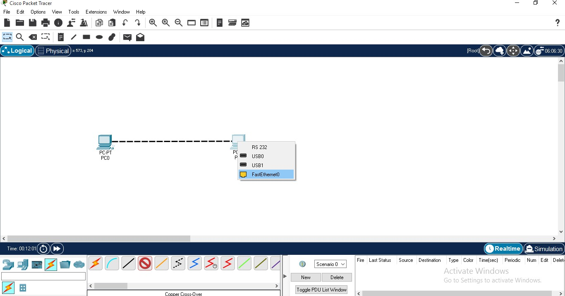

**STEP 04 -** Check design is correct or not, if there is a **green indicator** between the copper cross over cable connection then that means that the connection is established between the devices with no errors, and if there is a **red indicator** that means there is an error between the connections in devices.

Here, the connection is established successfully between PC0 and PC1.

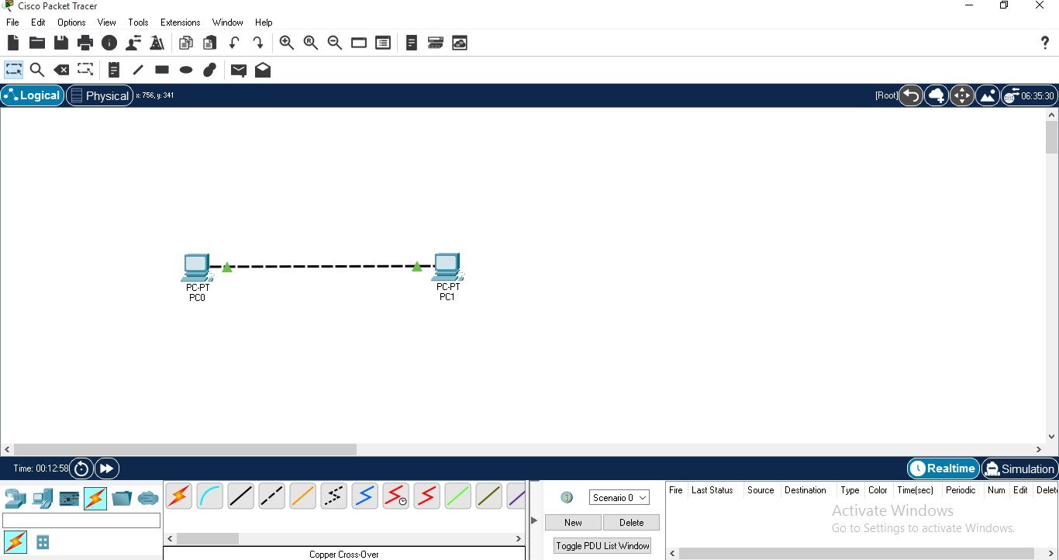

Click on PC0, a window will open and in that window click on the **desktop tab**.

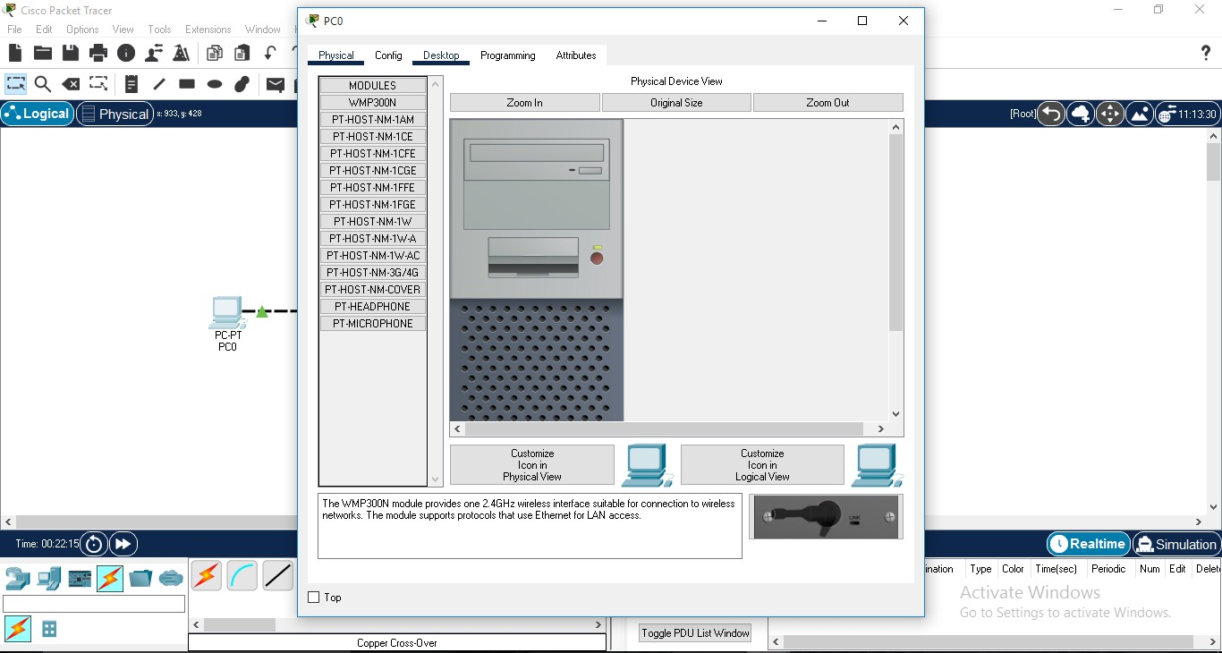

After clicking on desktop tab-

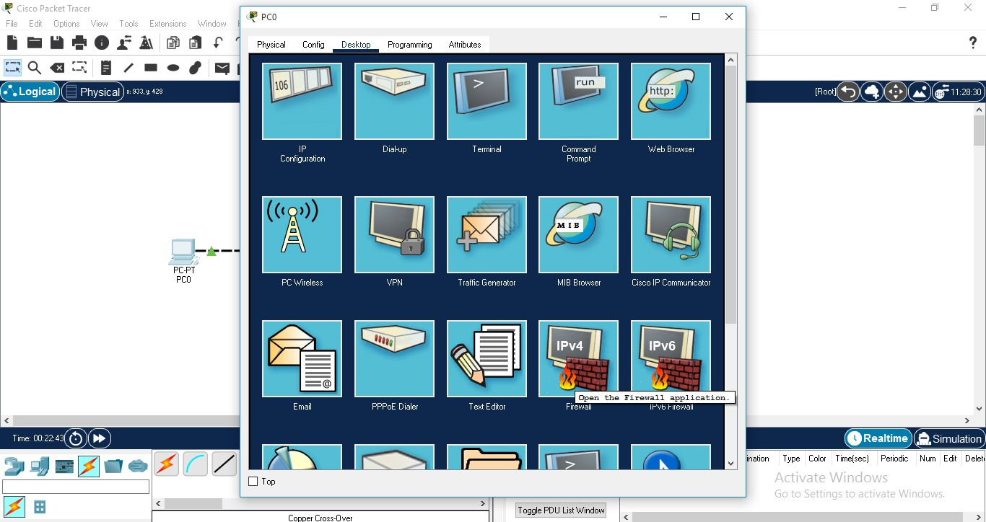

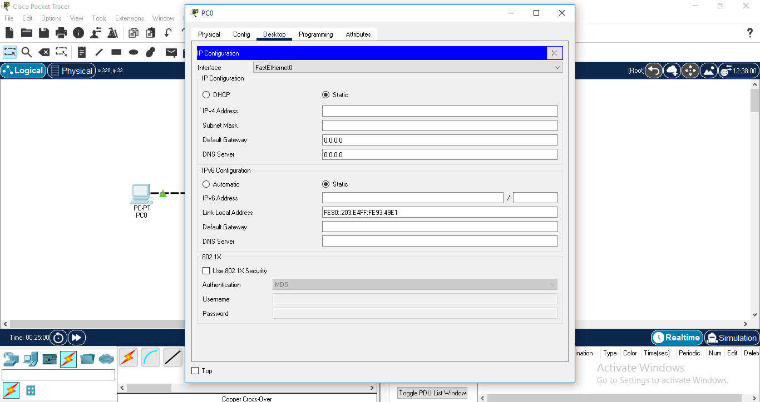

**STEP 07 -** Select **static** option, and then give IPv4 Address (**for eg. 192.168.10.1**) for PC0. After that click on Subnet Mask field it will fill automatically with default subnet mask.

After that the IP Configuration is done for PC0.

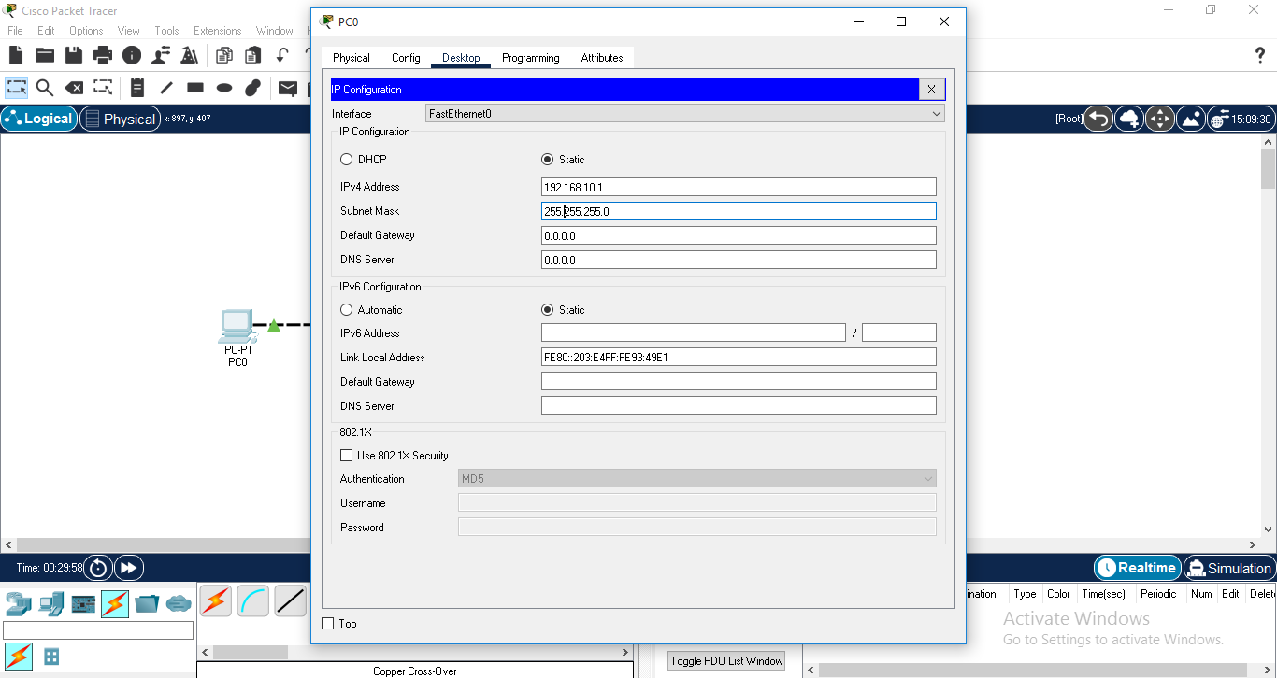

IP Configuration of PC1.

Click on PC1, a window will open and in that window click on the **desktop tab**. And repeat all steps.

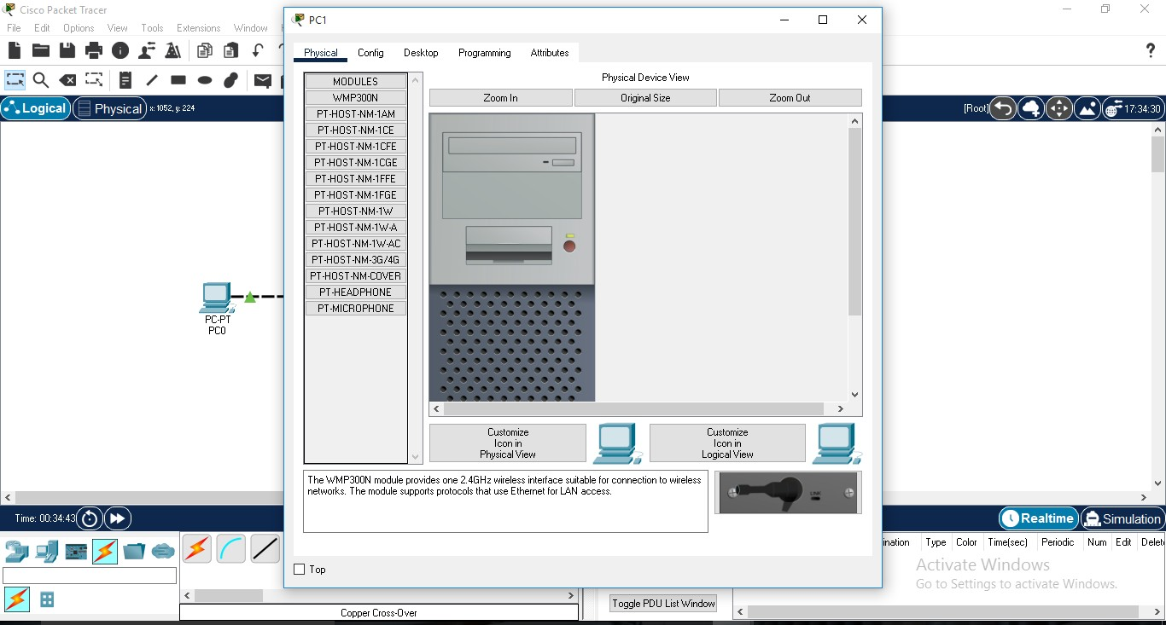

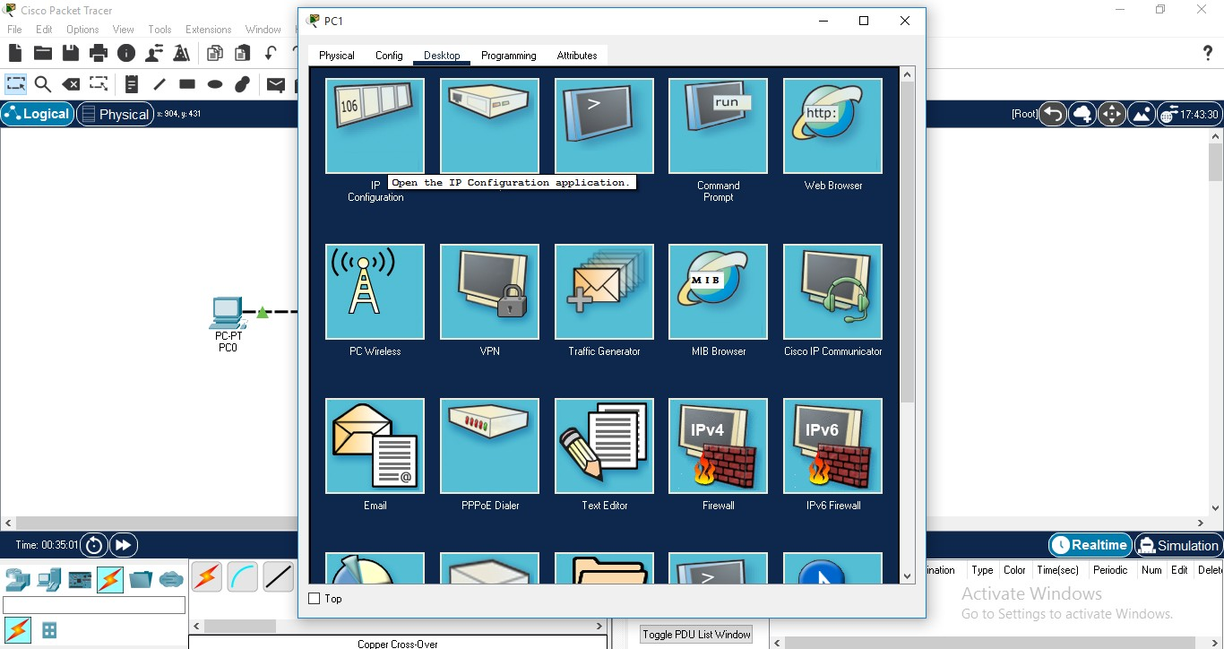

that click on Subnet Mask field it will fill automatically with default subnet mask. After that the IP Configuration is done for PC1.

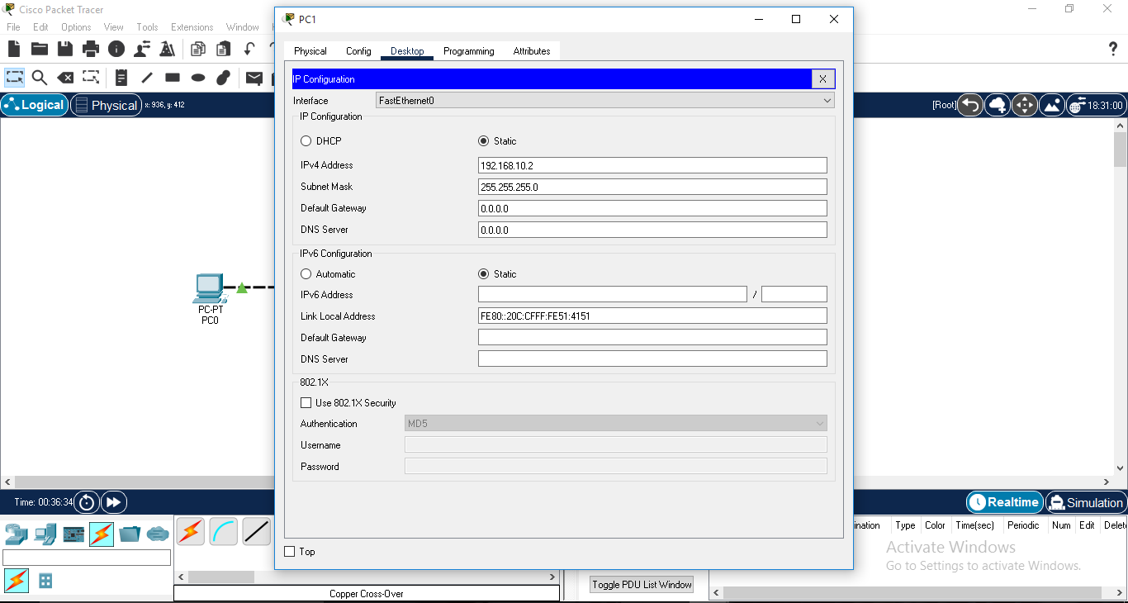

**STEP 10 -** Check our design is working or not, click on PC0 then click on command prompt.

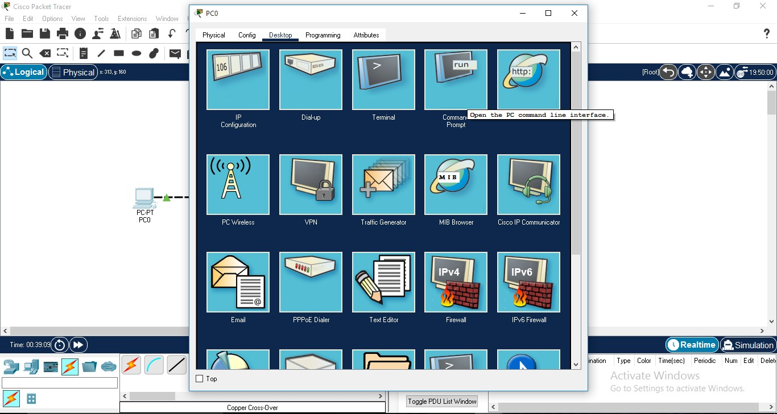

have to give the IP address of PC1) on terminal to check or to test the connectivity between the devices.

(We can perform same with PC1 as well to check connectivity using ping command.)

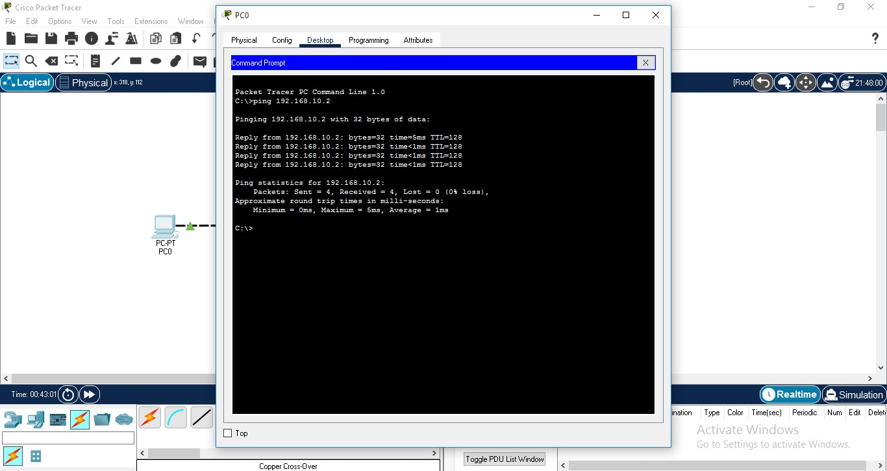

# SO, BOTH SYSTEMS ARE CONNECTED TO EACH OTHER.